What is an Use-Case Diagram

A [**UML**](https://en.wikipedia.org/wiki/Unified_Modeling_Language) use case diagram is the primary form of system/software requirements for a new software program underdeveloped. Use cases specify the expected behavior (what), and not the exact method of making it happen (how). Use cases once specified can be denoted both textual and visual representation (i.e. use case diagram). A key concept of use case modeling is that it helps us design a system from the end user's perspective. It is an effective technique for communicating system behavior in the user's terms by specifying all externally visible system behavior.

A use case diagram is usually simple. It does not show the detail of the use cases:

* It only summarizes **some of the relationships** between use cases, actors, and systems.
* It does **not show the order** in which steps are performed to achieve the goals of each use case.

Use Case Diagram for our project

* Registration Window
* Home Page
* Help index
* About Page

Registration Window Use-Case Diagram

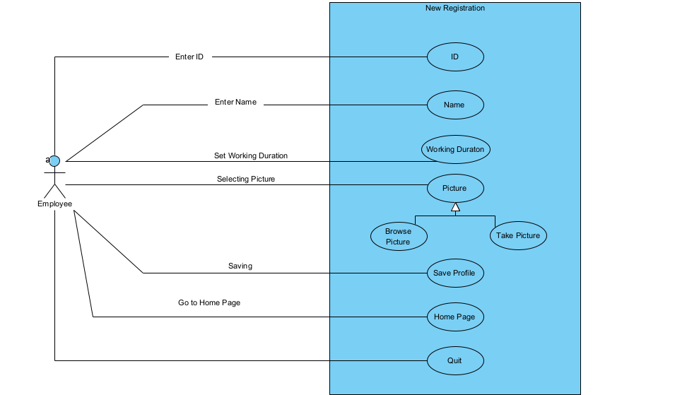

Home Page Use-Case Diagram

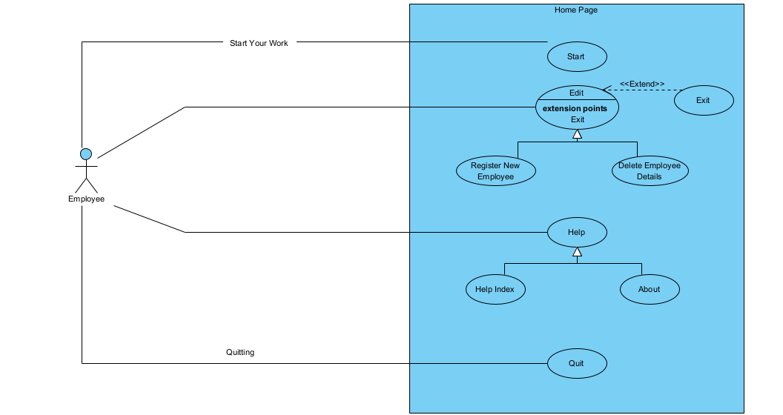

Help Index Use-Case Diagram

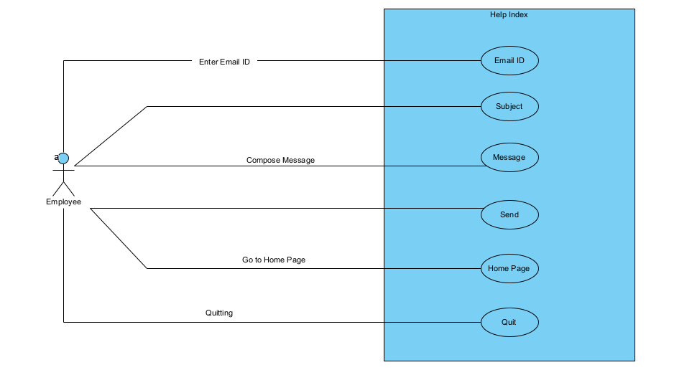

About Page Use-Case Diagram

